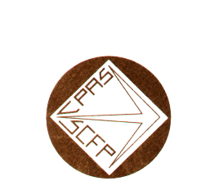
No. 23
NEGOTIATING COMMITTEE PROVINCIAL COUNCIL OF SOCIAL AFFAIRS

OF CANADIAN UNION OF PUBLIC EMPLOYEES (CUPE)

December 7th, 2005

THE GOVERNMENT MUST MOVE

SECTORIAL TABLE

This is where our main working conditions such as job security, provisions on outsourcing, salary insurance, etc. are negotiated.

Negotiations over the week-end and the beginning of the week did not result in anything significant. The employer is still maintaining its main demands such as sharing arbitration costs. Furthermore, the employer side is not budging with regards to our demands such as, for example, a substantial increase from the employer to the government insurance coverage in our group insurance plans. Let’s remember that presently the portion of the government in our group insurance plans for the public sector employees is approximately 4%. In the private sector, the employer contribution is quite often a minimum of 50%.

PAY EQUITY

After months of waiting, the employer has finally tabled with the house of labour its counter-proposal as to the value of jobs covering more than 80% of the public sector personnel. This document is being reviewed. We hope to be in a position to react as early as this week-end.

CENTRAL FTQ-CSN TABLE

The employer is still not budging from its initial proposal i.e. a contract for 6 years and 9 months with a salary freeze for the first two years and 2% per year for the following four years.

The two consecutive days of strike remaining to be used according to our initial action plan are therefore more than necessary.

Claude Turcotte
Secretary General

It is your responsibility to photocopy and to circulate this document.

Page 2

